

**Camfil APC's Stinger**™ **Explosion Isolation Valve**

**Keeps Dust Collectors Operating Safely**

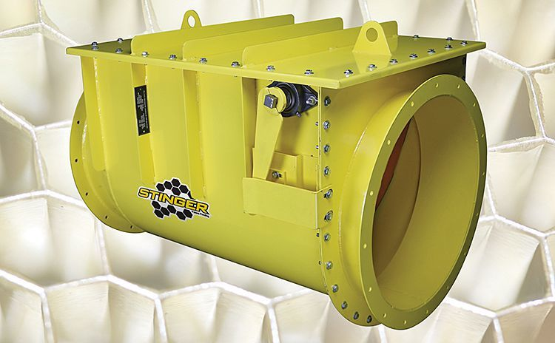JONESBORO, Ark., January 25, 2018 – If your dust collector handles combustible dust, the National Fire Protection Association (NFPA) requires you to equip your system with deflagration protection. That's why Camfil APC offers the Stinger™ explosion isolation valve, a cost-effective, NFPA-compliant way to contain a deflagration that occurs in a dust collector.

The flow-activated valve prevents an explosion, smoke, dust and burning debris from traveling back through the dust collector’s inlet pipe and into the workspace. It is thoroughly explosion tested and is designed and tested to meet NFPA & EN 1779 standards for a range of applications and dust types.

"What makes the Stinger so unique is the lightweight composite blade that saves energy and reacts faster than heavier steel blades in the event of an explosion," said Graeme Bell, Vice President of Camfil APC Americas." Also, these blades are easy to replace, and the front side is covered with abrasion-resistant rubber sheeting to protect it from wear."

[Click here](https://camfilapc.com/products/stinger) for more information about the NFPA-compliant Stinger explosion isolation valve. To directly purchase the Stinger explosion isolation valve, visit [www.CleanFactoryAir.com](http://www.CleanFactoryAir.com).

**About Camfil APC**

Camfil APC is a leading global manufacturer of dust, mist and fume collection equipment and is part of Camfil, the world’s largest air filtration company. For further information, contact Camfil APC at 1-800-479-6801 (U.S./Canada) or 1-870-933-8048 (Latin America); email [filterman@camfil.com](mailto:filterman@camfil.com), web [www.camfilapc.com](http://www.camfilapc.com).

# # #

***For media inquiries:***

|  |  |
| --- | --- |
| Lisa Goetz | Vince Brown |
| Schubert b2b | Camfil APC |
| 1-610-269-2100 x244 | 1-870- 910-7162 |
| [lgoetz@schubertb2b.com](mailto:lgoetz@schubertb2b.com) | [vince.brown@camfil.com](mailto:vince.brown@camfil.com) |

***For sales/reader service inquiries:***

Camfil APC

3505 S. Airport Road

Jonesboro, AR 72401

800-479-6801 or 870-933-8048

[filterman@camfil.com](mailto:filterman@camfil.com)