

**FOR IMMEDIATE RELEASE**

**Camfil APC Launches Website for Direct Purchase of High-Performance Dust Collector Filters**

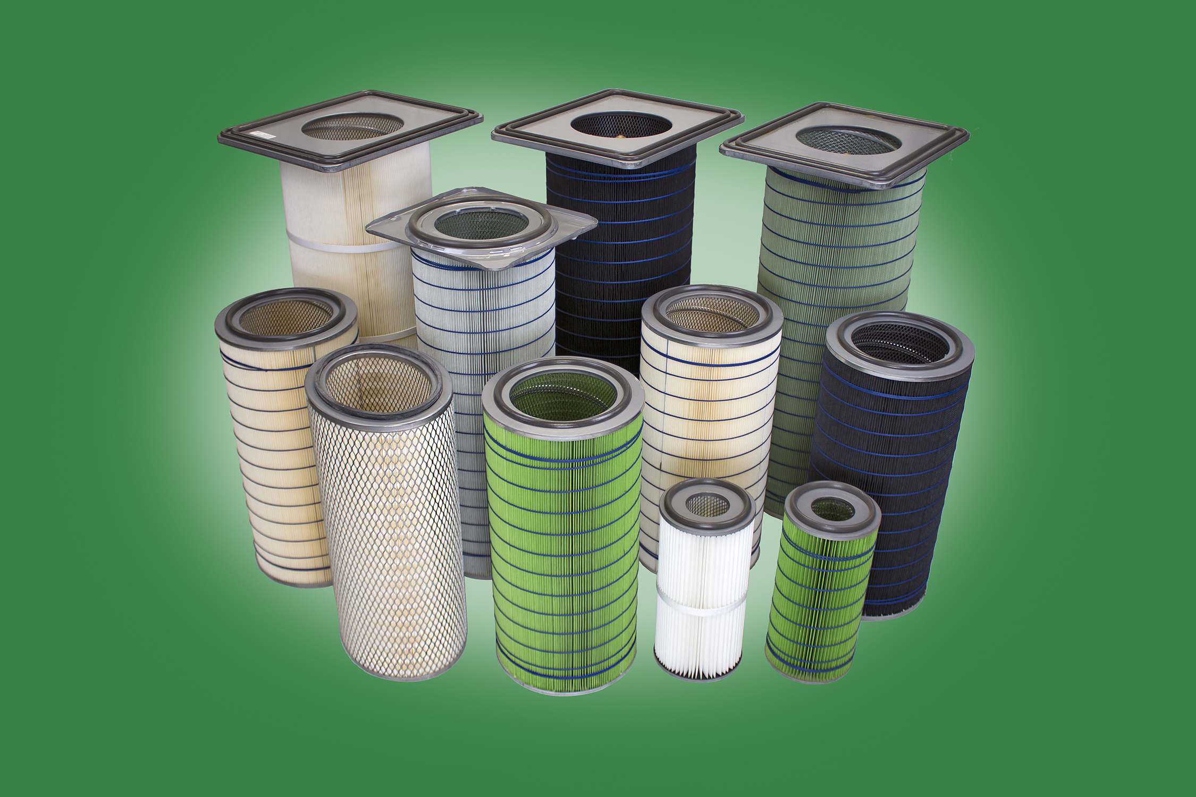JONESBORO, Ark., January 3, 2018 – Camfil APC has launched an eCommerce site that stocks high-performance retrofit filters for most leading dust collector brands. [CleanFactoryAir.com](http://www.cleanfactoryair.com) features HemiPleat® premium retrofit filter cartridges, which are guaranteed to last longer than standard filters.

HemiPleat filters also boost the performance of industrial dust collectors because they use a patented pleating technology that exposes more filter media to the air stream. They are far more efficient than standard filters, which means they need to be changed out less frequently, saving time and maintenance costs.

HemiPleat retrofit filters are available in a variety of media including standard, flame retardant, carbon impregnated or synthetic fibers. Visitors to the site can find their filters by entering a part number or selecting their brand and model.

"This new site offers a convenient way for manufacturers to purchase premium replacement dust collector filters that last longer," said Rick Kreczmer, director of aftermarket at Camfil APC Americas. "If they need more detailed consultation about our line of industrial dust and mist collectors, they can call us or visit our main site at [camfilapc.com](https://camfilapc.com/)."

[Click here](http://www.cleanfactoryair.com) to visit the new eCommerce site and learn more about these high-performance dust collector filters and accessories.

**About Camfil APC**

Camfil APC is a leading global manufacturer of dust, mist and fume collection equipment and is part of Camfil, the world’s largest air filtration company. For further information, contact Camfil APC at 1-800-479-6801 (U.S./Canada) or 1-870-933-8048 (Latin America); email [filterman@camfil.com](mailto:filterman@camfil.com), web [www.camfilapc.com](http://www.camfilapc.com).

# # #

***For media inquiries:***

|  |  |
| --- | --- |
| Lisa Goetz | Vince Brown |
| Schubert b2b | Camfil APC |
| 1-610-269-2100 x244 | 1-870- 910-7162 |
| [lgoetz@schubertb2b.com](mailto:lgoetz@schubertb2b.com) | [vince.brown@camfil.com](mailto:vince.brown@camfil.com) |

***For sale inquiries:***

Camfil APC

3505 S. Airport Road

Jonesboro, AR 72401

800-479-6801 or 870-933-8048

[filterman@camfil.com](mailto:filterman@camfil.com)